**DEPARTMENT OF MECHANICAL ENGINEERING  
  
Subject: Fundamentals of Programming  
Assignment No. 5  
Submitted by: Muhammad Maaz  
Registration number: 479510  
Semester No. 1  
Date: DECEMBER 25, 2023**

**FIRST PROGRAM**

#include<iostream>

#include<vector>

using namespace std;

int main(){

int n=0;

cout<<"enter the number of elements in your vector: ";

cin>>n;

vector<int>v(n);

for(int i=0;i<v.size();i++){

cin>>v[i];

}

vector<int>::iterator it;

for(it=v.begin();it!=v.end();it++){

cout<<*it<<" ";

}

cout<<endl;

v.push_back(5);

for(it=v.begin();it!=v.end();it++){

cout<<*it<<" ";

}

cout<<endl;

v.pop_back();

for(it=v.begin();it!=v.end();it++){

cout<<*it<<" ";

}

return 0;

}

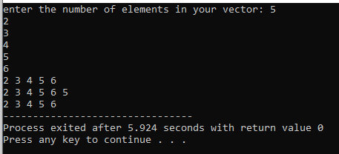

**SECOND PROGRAM**

#include <iostream>

#include <vector>

#include <algorithm>

#include <numeric>

using namespace std;

int main() {

int numPairs;

cout << "Enter the number of name/grade pairs: ";

cin >> numPairs;

vector<string> names(numPairs);

vector<int> grades(numPairs);

for (int i = 0; i < numPairs; i++) {

cout << "Enter name of student" << i + 1 << ": ";

cin >> names[i];

cout << "Enter grade of " << names[i] << ": ";

cin >> grades[i];

}

double mean = accumulate(grades.begin(), grades.end(), 0.0) / numPairs;

cout << "Mean grade: " << mean << endl;

sort(grades.begin(), grades.end());

double median = (numPairs % 2 == 0)

? (grades[numPairs / 2 - 1] + grades[numPairs / 2]) / 2.0

: grades[numPairs / 2];

cout << "Median grade: " << median << endl;

int modeCount = 1, maxModeCount = 1;

int mode = grades[0];

for (int i = 1; i < numPairs; i++) {

if (grades[i] == grades[i - 1]) {

modeCount++;

} else {

modeCount = 1;

}

if (modeCount > maxModeCount) {

maxModeCount = modeCount;

mode = grades[i];

}

}

cout << "Mode grade: " << mode << endl;

cout << "name of student with mode grade: ";

for (int i = 0; i < numPairs; i++) {

if (grades[i] == mode) {

cout << names[i] << " ";

}

}

cout << endl;

return 0;

}

